Knee Meniscal/Cartilage Irritation

Within the knee joint there are two main areas of ‘C’ shaped cartilage. Throughout our lives this can change in relation to age, repetitive load placed through knee, and trauma. Occasionally tears can develop within the cartilage which sometimes improve with physiotherapy but do sometimes require orthopaedic referral. For most the cartilage can become irritated causing pain but generally very minimal swelling, if any at all. Due to limited blood supply to parts of the cartilage it can be slow to recover, research does suggest anything up to 6 months is normal.

Pacing Physical Activity:

It is important to pace out your physical activities and ensure it feels ok later that evening/next day. Modify some of your activities to allow your knee some relative rest in the short term.

Pain management methods:

Speak to your GP/pharmacist about some pain medication if needed
Cold/Heat packs 10-15 minutes daily and/or after exercise – ensure if using cold that it is wrapped in damp towel or through clothing to prevent ice burns

Exercises:

We would recommend you try the following. If your symptoms increase/worsen then we suggest you seek advice from the physiotherapist and stop exercises if unable to manage.

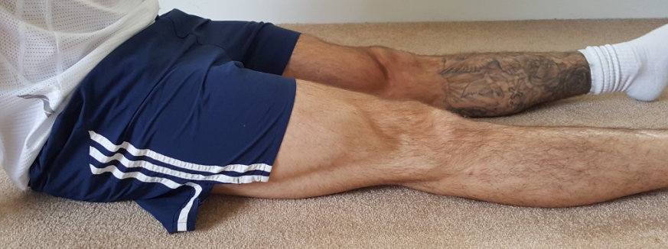
Static Quad

- Straight leg
- Press knee down into floor/bed
- Hold for 10 seconds
- Relax

Repetitions…………………………………..

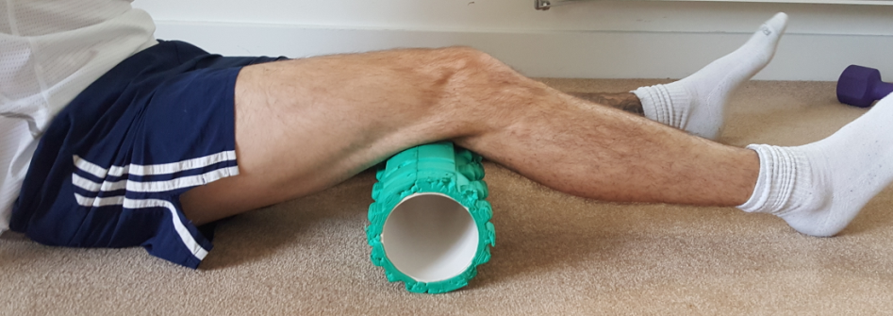
Inner Range Quads

- Place a rolled up towel or pillow under your knee
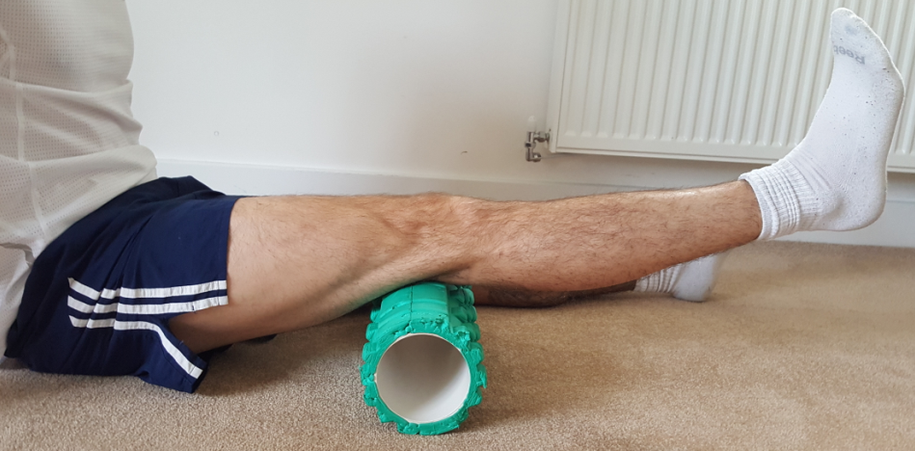
- Press the knee down into the towel/pillow
- Lift up your foot at the same time to straighten the leg
- Hold for 10 seconds
- Relax

Repetitions………………………………….

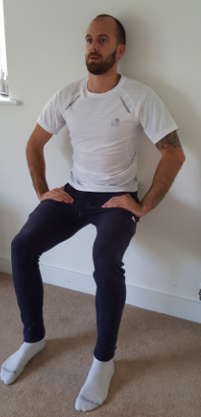
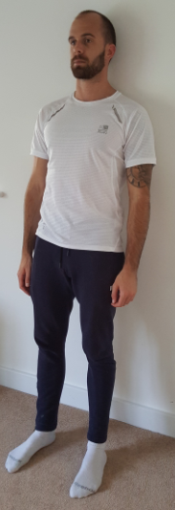
Wall Squats

- Lean back against a sturdy/solid wall
- Walk your feet forwards, placed about hip width apart
- Slide your body down the wall
- As far as you feel comfortable
- Push yourself back up

Repetitions…………………………………………..

